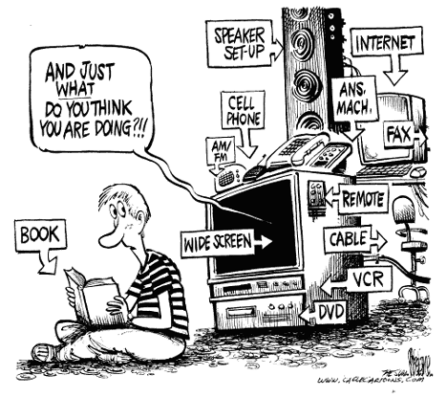  Welcome to 6th Grade Language Arts!  I am really excited to be working with your child this year in developing their language arts skills. My goal is to instill a love of reading and writing in your child. We will work together to build upon their strengths, improve their weaknesses, and deepen their ability to think and question.  I believe every child has the ability to learn and grow. My job is to help them on their journey and inspire them to always strive for more!  About Me:  “Once a Brickie… Always a Brickie!”  I grew up in Hobart and attended Liberty Elementary, Hobart Middle School and Hobart High School. I graduated from Hobart High School in 2004 with High Distinction. I attended Indiana University in Bloomington where I received my Bachelors Degree in Education with Highest Distinction. I did my student teaching in 5th grade, taught for 2 years at Hayes Leonard Elementary School in Valparaiso then I decided to return to Hobart. I taught 6th grade Language Arts and Social Studies last year. This year I am excited to be focusing on language arts! I live in Hobart with my husband, 2 daughters, and pug Hoosier. I love to read and play with my girls. I am also Hobart High School’s diving coach! |  | Mrs. Rinas  Rm. 1605  Syllabus of Skills  1st Quarter  Main Idea  Sequence of Events Text Features  Using Context Clues Author’s Purpose  Grammar/ Writing Spelling  S  2nd Quarter  Problem/ Solution Narrative  Drama  Story Elements  Making Inferences Cause and Effect  Fables and Morals Author’s Style  Grammar / Writing Spelling  Cause/Effect Essay  Fictional Narrative  [You Have Room for Another One Here!]  Parent Conferences  I am happy to meet with you! Email me to confirm time.  Before school: 6:45-7:25  After School: 2:35- 3:00  Prep time:  Lunch time:
Course Description:  Expert 21 is a comprehensive English Language Arts curriculum that prepares students for the literacy demands of the 21st Century through a powerful combination of explicit instruction, inquiry-based learning, contemporary and relevant literature and informational texts, real-world writing and projects, and technology. Ever hear about that guy who cut off his own arm? We will read his story! Students will have daily opportunities to reflect, respond, react, inform, analyze and more, both in writing and through classroom discussions.  Expert 21 is divided into themed workshops. We are using volume 2 and will work through workshops 5-8.  Workshop 5: Progress test 5a SRI (not for grade)  Workshop 6: Progress tests 5b, 6 a, 6b X-Skills Test 5 and 6 Fictional Narrative Cause and Effect Essay SRI (not for grade)  Workshop 7: Progress tests 7a, 7b X-Skills Test 7 Research Paper SRI (not for grade)  Workshop 8: Progress tests 8a, 8b X-Skills Test 8 SRI ( not for grade)  Classwork/ Assignments/ Projects/ Tests  Each day in class is so essential for your student! Most work will be done in class. Homework assignments will mainly consist of spelling work and reading (reading logs). Each student is expected to read independently each day. Your child will also write 4 main papers this school year, work on 2-3 projects, and be assessed in many ways to inform instruction. More information regarding assignments, projects, papers, and tests will be provided as dates get closer.  Literature Circles / Novels  In addition to the readings in Expert 21, we will explore several novels this year! ------------------------------------ |  | Syllabus of Skills  6th  3rd Quarter  Summarize  Point of View  Figurative Language  Drawing Conclusions  Grammar/ Writing Spelling  Research Paper  S  4th Quarter  Fact and Opinion Compare and Contrast  Elements of Poetry  Symbolism  Theme  Cause and Effect  Grammar / Writing Spelling  Persuasive Essay  3rd Quarter  4th Quarter  Class Novels  There’s a Girl in My Hammerlock  Wringer  Stargirl  Crash  Loser  Maniac McGee  Julie of the Wolves  Elijah  Number the Stars  Miracle Worker

